Using Information in your assignments: avoiding plagiarism
Q: Why do I need to cite my sources?
A: You must acknowledge in full all information sources you have used. If you fail to do this it could amount to plagiarism!
Referencing supports your arguments and gives your work a factual basis. It also enables the reader to locate the resources you have consulted and demonstrates to assessors that you have carried out the necessary research.
Quoting
Whenever you copy an author’s exact words into your own work you must “enclose them in quotation marks”. Then cite the author’s last name, the date of publication and the page number on which you found the quote. Finally, write a full reference at the end of your work.
Be selective in your use of quotes. It is preferable to demonstrate your understanding of the topic in your own words.
You may want to use a quote if the:
- information cannot be presented more succinctly or in any other way
- phrase is unusual and would have less impact if paraphrased
- quote substantiates your argument
Paraphrasing
When you write about information you have found from another source in your own words, this is considered to be paraphrasing. Whenever you paraphrase from another source you must always provide a citation in your text and a full reference at the end. It is plagiarism to include too many words from the original text when paraphrasing even if you provide a reference.
A good tip is to read the text and then cover it over while you write down the information in your own words. Then compare what you have written with the text.
When should you cite?
Cite your source in your text and provide a full reference at the end when you
- paraphrase
- summarise
- quote
- refer to the ideas or theories of another work in your assignments.
For a comparison of quoting, summarising and paraphrasing, please see the table below.
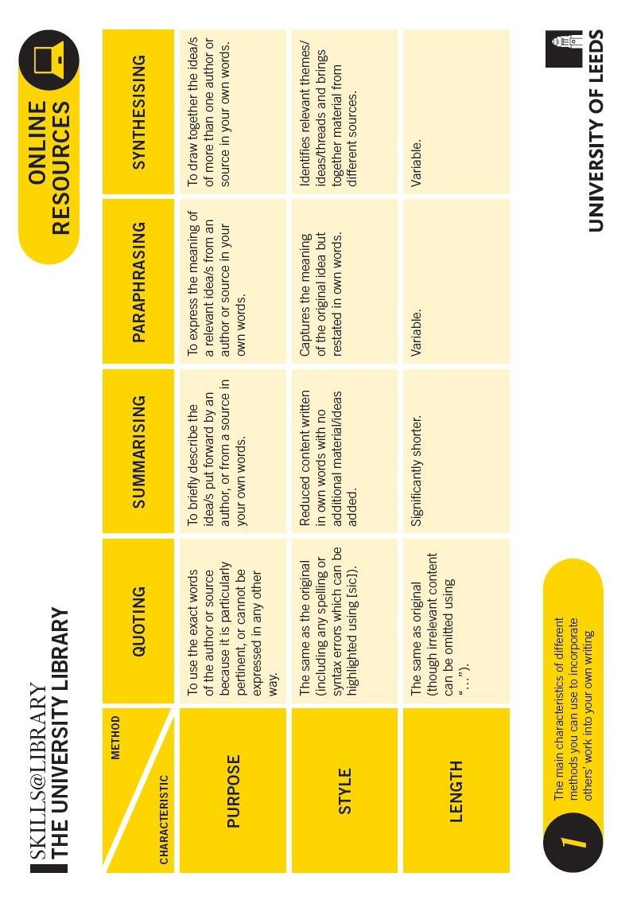 | Quoting, summarising, paraphrasing and synthesising comparison table by Skills @ Leeds is licensed under CC BY 2.0

If you’re confused about when you should cite, try using this flowchart:
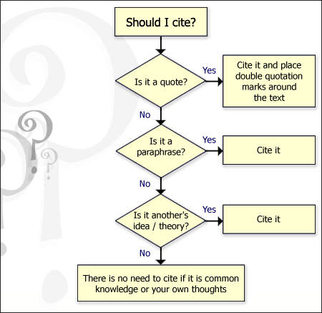

Q: What is common knowledge?
A: It is not necessary to provide a reference when you write about something that is common knowledge. Common knowledge is a fact which is generally well known in your field of study or the wider world. Opinions can sometimes differ on whether a piece of information is common knowledge and so if in doubt you should always provide a reference.

What is plagiarism?
Is it plagiarism if you…
Yes | No
Yes | No
Yes | No
Yes | No
Yes | No
Yes | No

Copy and paste a paragraph of text from a web site without enclosing it
in quotation marks and referencing the source? Yes. When you copy the exact words from another source you must enclose them in the quotation marks and provide a reference.

Use the ideas of another author without providing a reference even if you write them in your own words? Yes. Even if you do not directly copy the author's words you must provide a reference when you talk about their ideas.

Claim work produced by another student as your own? Yes. This is a form of plagiarism. Buying, stealing or copying an essay to produce your work is plagiarism. Collaborating with another student (unless requested by your tutor) is also plagiarism.

Copy a diagram or data table from a web site, providing a reference for the source underneath? No. You can include a table, diagram or image from another source as long as you provide a reference.

Submit all or part of one essay for two separate assignments? Yes. Although this may surprise you, self-plagiarism is a form of plagiarism.

Copy words from a book into your own work, but place quotation marks around them and provide a citation & reference? No. It is not plagiarism to copy words from another source as long as you place them in quotation marks and provide a reference.
Yes | No

Include a fact or saying in your assignment which is generally known without referencing the original source? No. If a fact is generally well known or 'common knowledge' then you don't need to reference it. Bear in mind that what you consider common knowledge may not be well
known to others, if in doubt provide a reference.

Yes | No
Change a few words from the original source and provide a citation & reference? Yes. If you do not intend to quote directly from the source, you must write about it in your own words. Using too many words from the original source is plagiarism, even if you provide a reference.

Citing & referencing help

Go to the student intranet http://intranet.cf.ac.uk - then click on Your study → Study skills → Manage, cite and reference information:

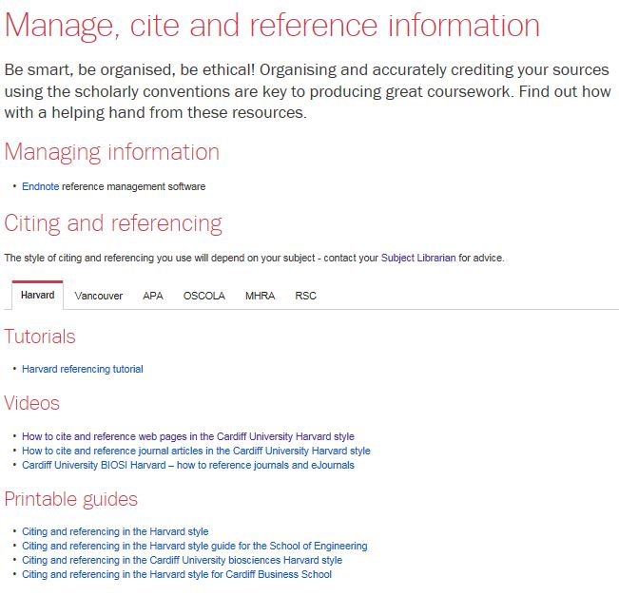
Videos

See pg. 6 of this handout for an extract from this guide

For guidance on paraphrasing and plagiarism go to Your study → Study skills → Writing and presenting.

Cardiff Harvard style

